**Decreto per i 55.000**

**firmato dai Ministri Fornero e Grilli del quale aspettiamo ancora la pubblicazione sulla Gazzetta Ufficiale.**[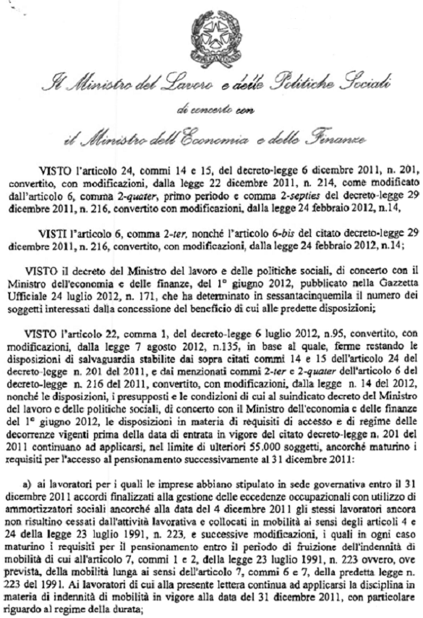](http://1.bp.blogspot.com/-Uk2jKKHUVwE/UHkutTZfezI/AAAAAAAAJ5o/GiuTy_1oY1k/s1600/001.png)

[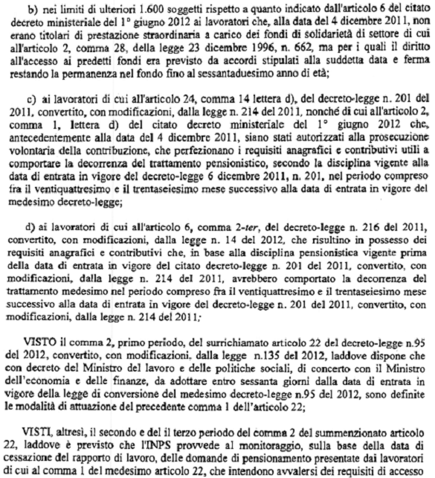](http://3.bp.blogspot.com/-TP57f4zMMGU/UHkuwwKT2HI/AAAAAAAAJ5w/nV3S1Ko97g8/s1600/002.png)

[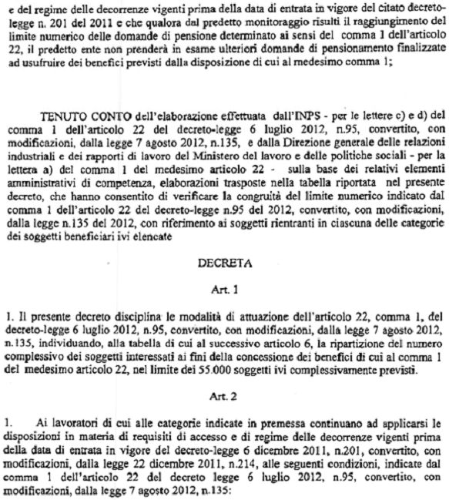](http://2.bp.blogspot.com/-yReW-1SeAqo/UHkvBA9mafI/AAAAAAAAJ54/dmLBnpfXX5U/s1600/003.png)

[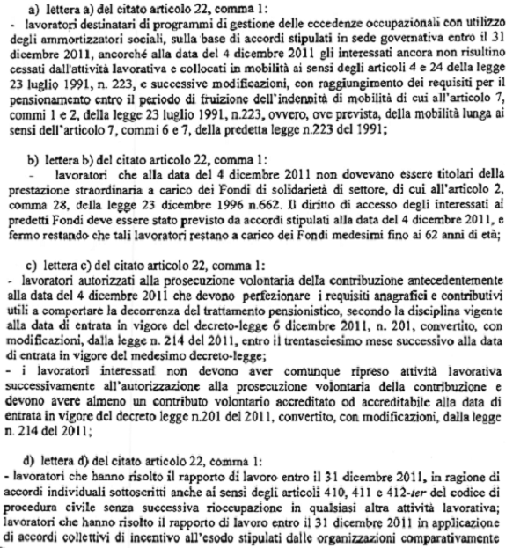](http://1.bp.blogspot.com/-DNp6C7dsqgM/UHk2FOXDxdI/AAAAAAAAJ6g/PWBmVkE5PMM/s1600/004.png)

[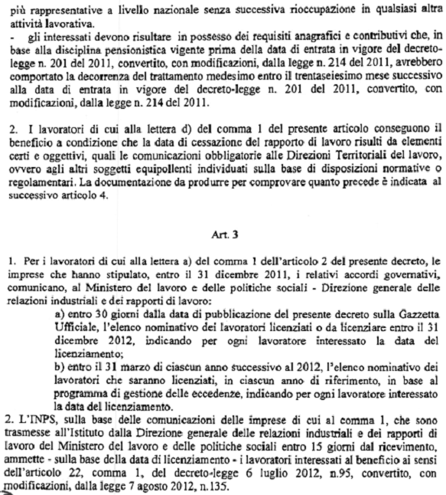](http://3.bp.blogspot.com/-9AcOPTUozkE/UHk2RCPvHRI/AAAAAAAAJ6o/iY_apWc88Qs/s1600/005.png)

[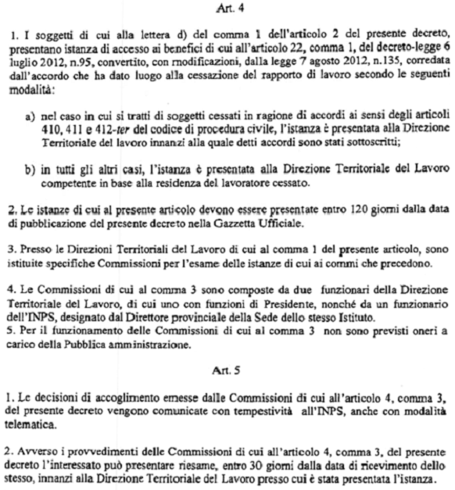](http://1.bp.blogspot.com/-lT2PH4z-WUM/UHk2gtASlrI/AAAAAAAAJ6w/Z6cSZZKDu28/s1600/006.png)

[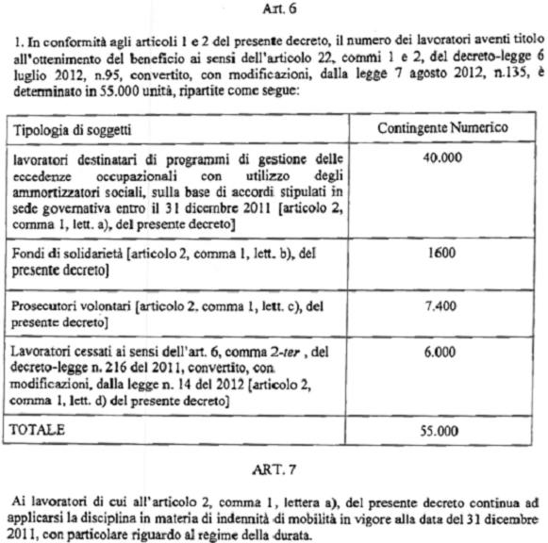](http://3.bp.blogspot.com/-49aCGekimWc/UHk6VxvvgEI/AAAAAAAAJ7Y/yQ5w9pz6sDA/s1600/007.png)

[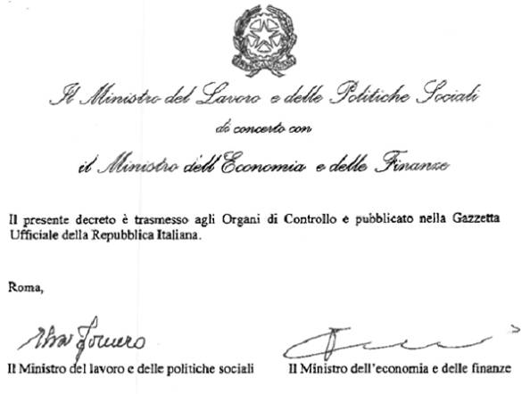](http://4.bp.blogspot.com/-IcEZH5noOQs/UHk6Ybf8z3I/AAAAAAAAJ7g/rZrEZvEEeqQ/s1600/008.png)